Test Case: tc001_SPX_Dev5_Crear_Nueva_Linea_Requisicion_Spot_Tipo_Cobro_CC
Step 1 - Enter username and password and click to button Enter : Credentials Entered
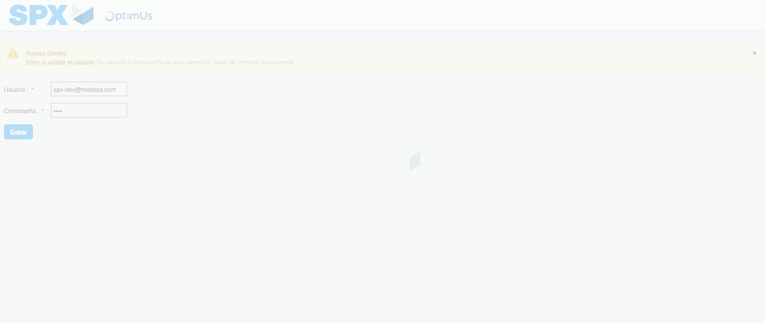Image file-name: QC_Testing-tc001_SPX_Dev5_Crear_Nueva_Linea_Requisicion_Spot_Tipo_Cobro_CC-1790176314124

Step 2 - Select to UEN and Access to Spot Buy Requisitions : UEN Correctly selected and Correct access
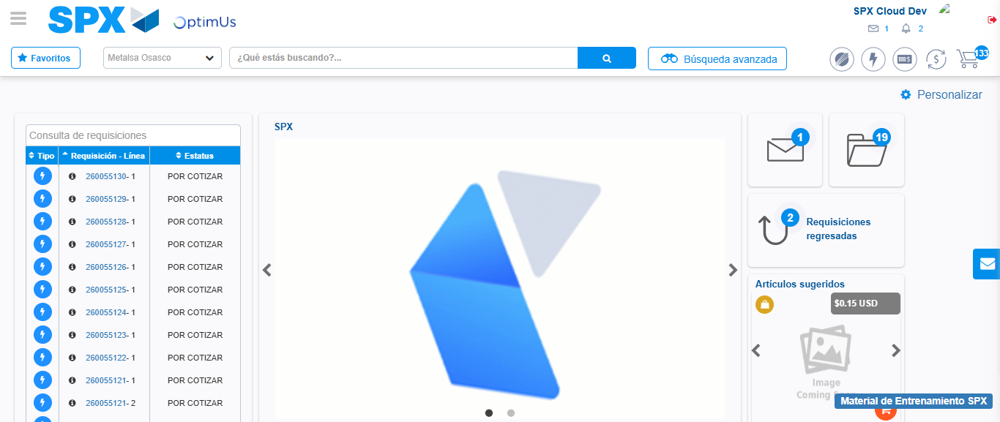Image file-name: QC_Testing-tc001_SPX_Dev5_Crear_Nueva_Linea_Requisicion_Spot_Tipo_Cobro_CC-1790176337778

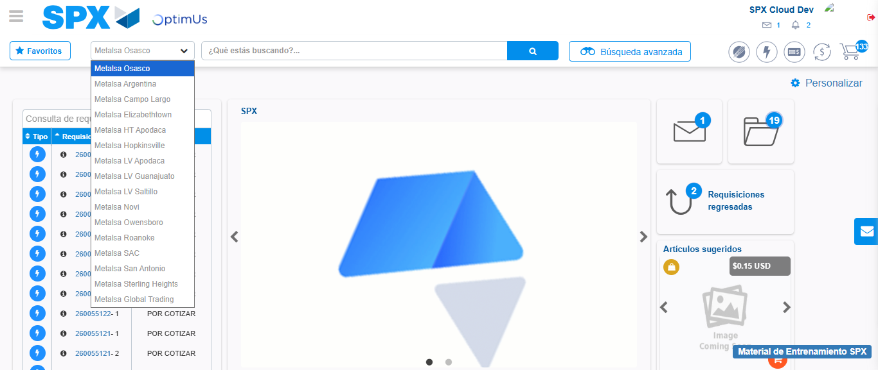Image file-name: QC_Testing-tc001_SPX_Dev5_Crear_Nueva_Linea_Requisicion_Spot_Tipo_Cobro_CC-1790176338415

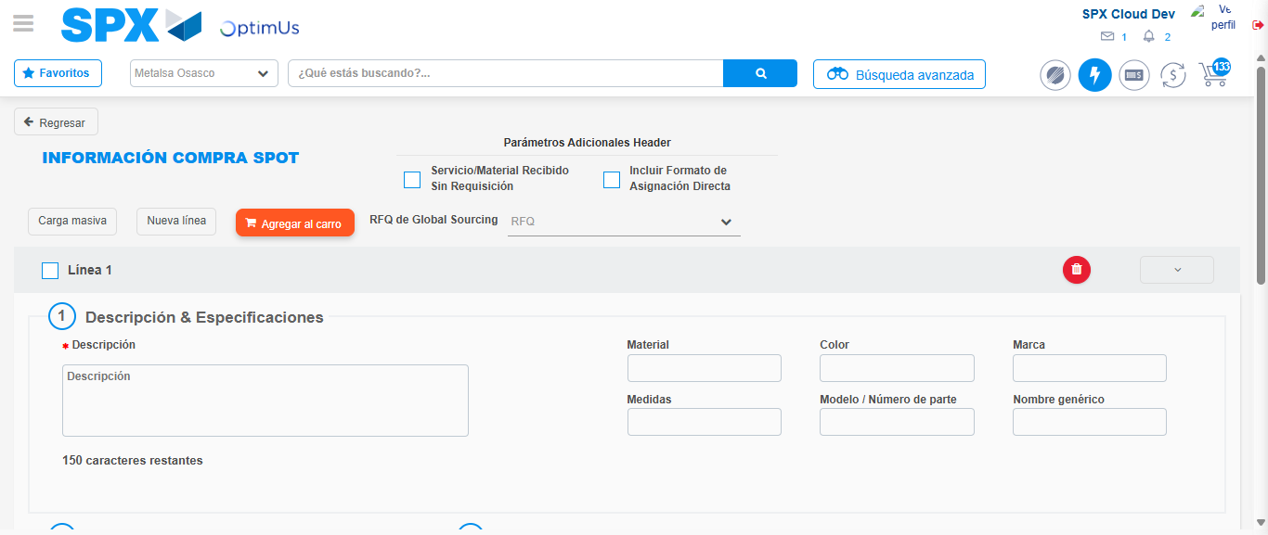Image file-name: QC_Testing-tc001_SPX_Dev5_Crear_Nueva_Linea_Requisicion_Spot_Tipo_Cobro_CC-1790176343505

Step 3 - Data Capture Spot Buy Requisition: Data captured correctly
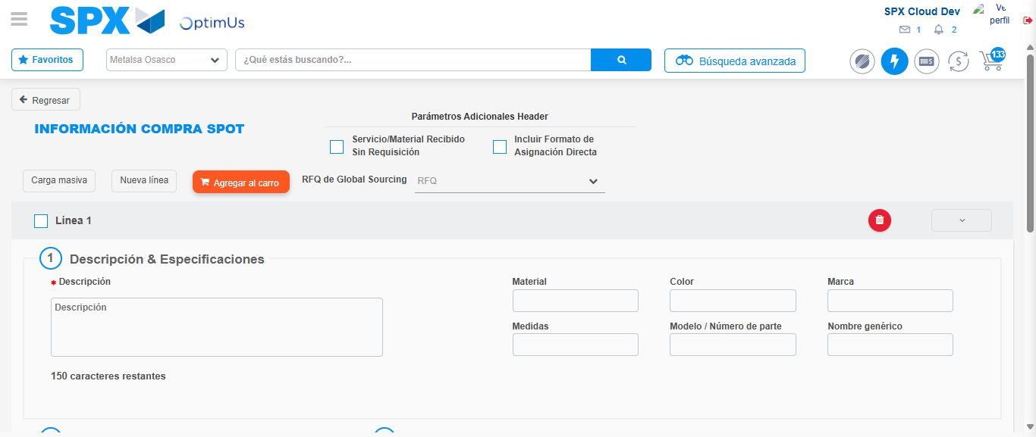Image file-name: QC_Testing-tc001_SPX_Dev5_Crear_Nueva_Linea_Requisicion_Spot_Tipo_Cobro_CC-1790176343806

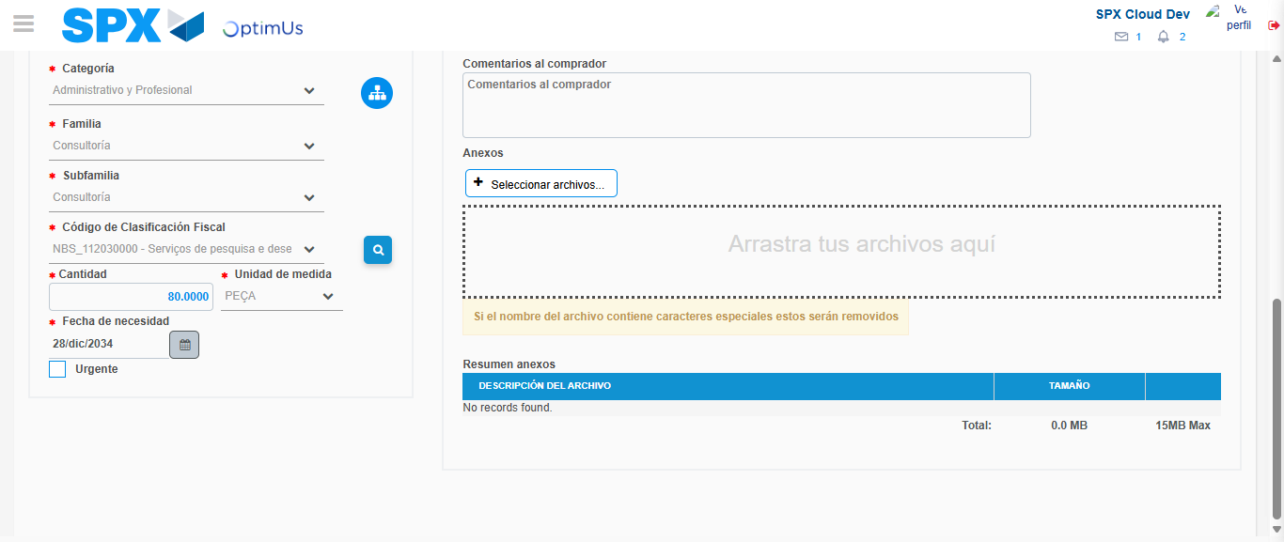Image file-name: QC_Testing-tc001_SPX_Dev5_Crear_Nueva_Linea_Requisicion_Spot_Tipo_Cobro_CC-1790176360360

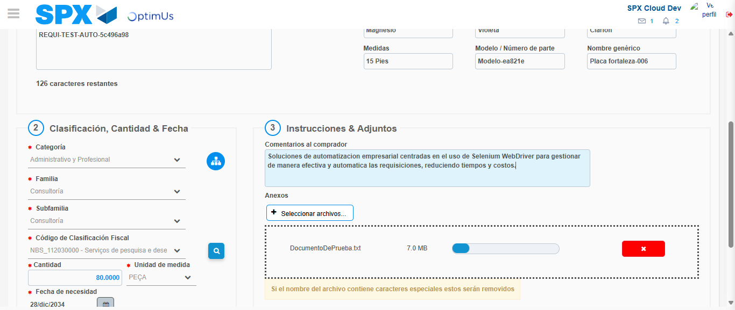Image file-name: QC_Testing-tc001_SPX_Dev5_Crear_Nueva_Linea_Requisicion_Spot_Tipo_Cobro_CC-1790176361259

Step 4 - Add new line and data capture second line: Line add correctly
Image file-name: QC_Testing-tc001_SPX_Dev5_Crear_Nueva_Linea_Requisicion_Spot_Tipo_Cobro_CC-1790176343806

Image file-name: QC_Testing-tc001_SPX_Dev5_Crear_Nueva_Linea_Requisicion_Spot_Tipo_Cobro_CC-1790176360360

Image file-name: QC_Testing-tc001_SPX_Dev5_Crear_Nueva_Linea_Requisicion_Spot_Tipo_Cobro_CC-1790176361259

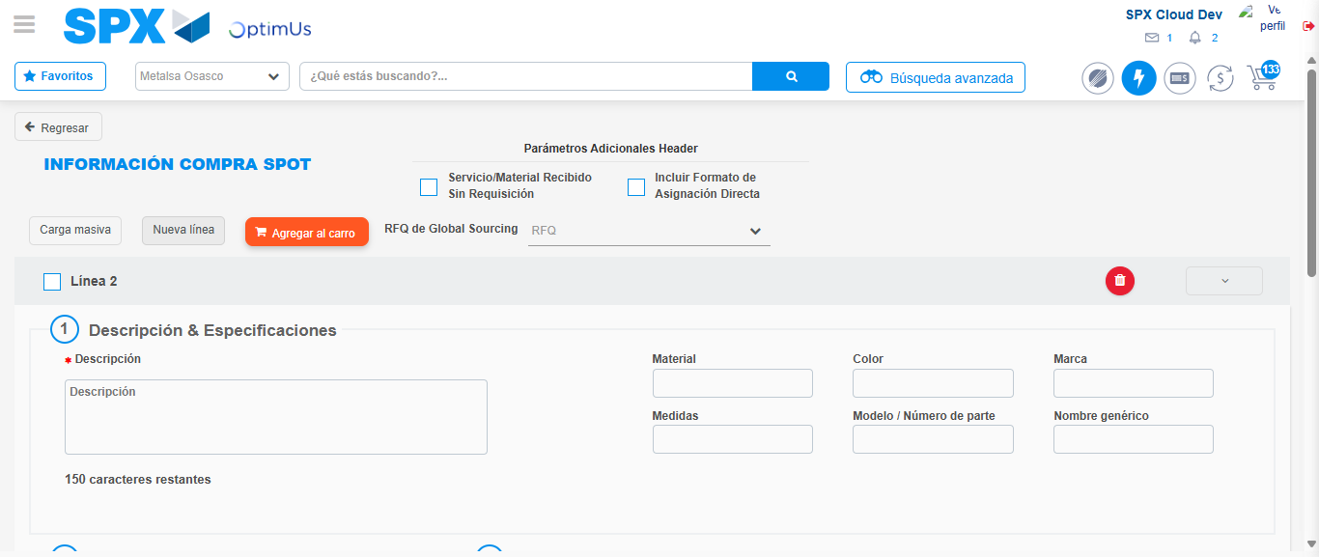Image file-name: QC_Testing-tc001_SPX_Dev5_Crear_Nueva_Linea_Requisicion_Spot_Tipo_Cobro_CC-1790176363616

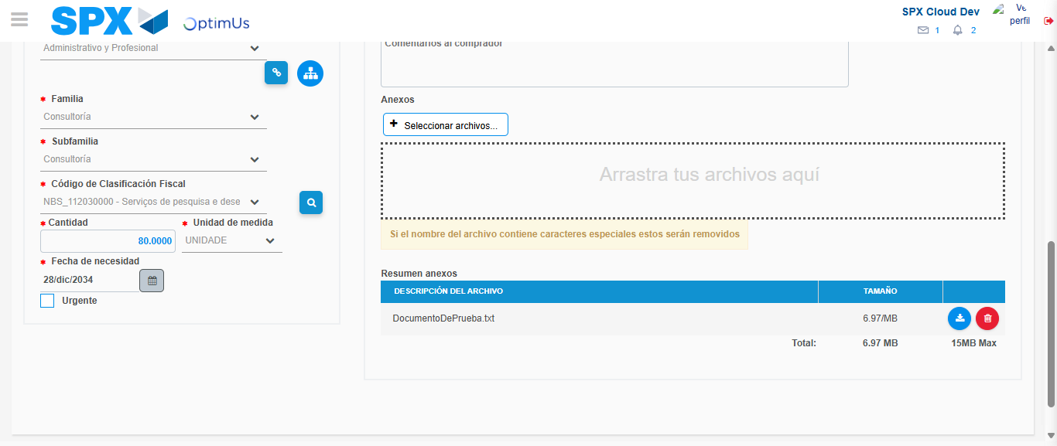Image file-name: QC_Testing-tc001_SPX_Dev5_Crear_Nueva_Linea_Requisicion_Spot_Tipo_Cobro_CC-1790176380830

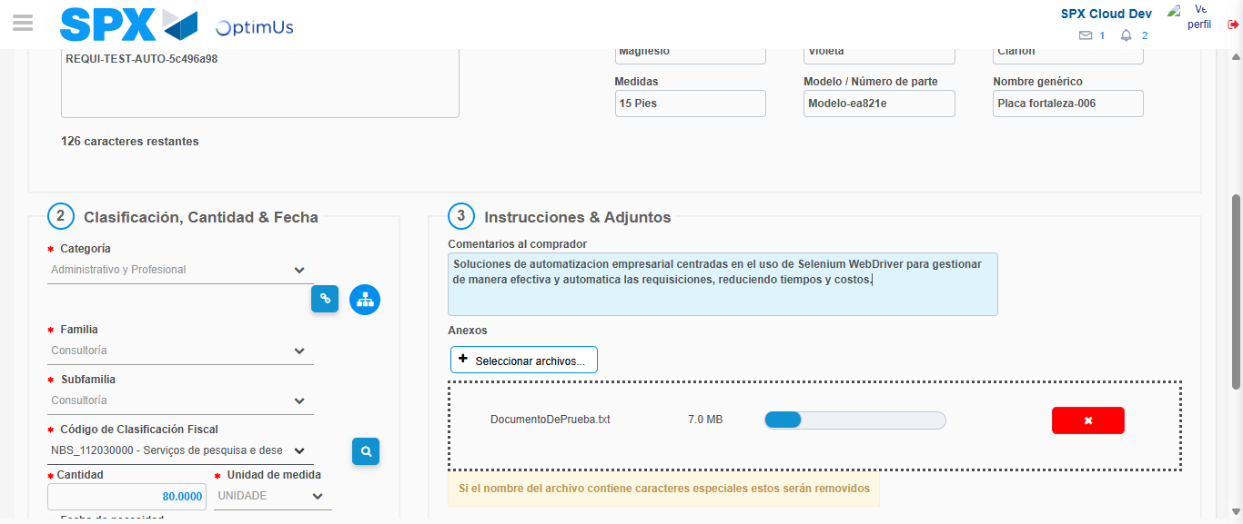Image file-name: QC_Testing-tc001_SPX_Dev5_Crear_Nueva_Linea_Requisicion_Spot_Tipo_Cobro_CC-1790176381772

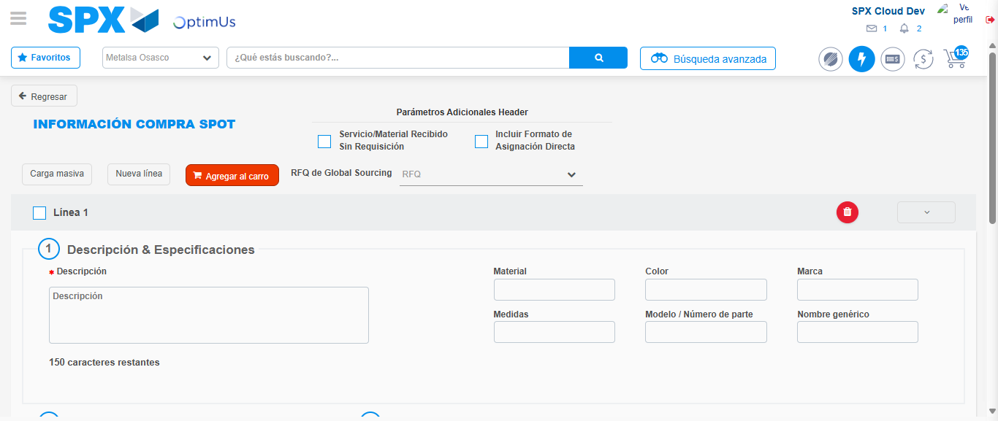Image file-name: QC_Testing-tc001_SPX_Dev5_Crear_Nueva_Linea_Requisicion_Spot_Tipo_Cobro_CC-1790176389920

Step 8 - Return to Main Page SPX : Return to Main Page SPX
Image file-name: QC_Testing-tc001_SPX_Dev5_Crear_Nueva_Linea_Requisicion_Spot_Tipo_Cobro_CC-1790176337778

Image file-name: QC_Testing-tc001_SPX_Dev5_Crear_Nueva_Linea_Requisicion_Spot_Tipo_Cobro_CC-1790176338415

Image file-name: QC_Testing-tc001_SPX_Dev5_Crear_Nueva_Linea_Requisicion_Spot_Tipo_Cobro_CC-1790176343505

Image file-name: QC_Testing-tc001_SPX_Dev5_Crear_Nueva_Linea_Requisicion_Spot_Tipo_Cobro_CC-1790176392208

Image file-name: QC_Testing-tc001_SPX_Dev5_Crear_Nueva_Linea_Requisicion_Spot_Tipo_Cobro_CC-1790176392404

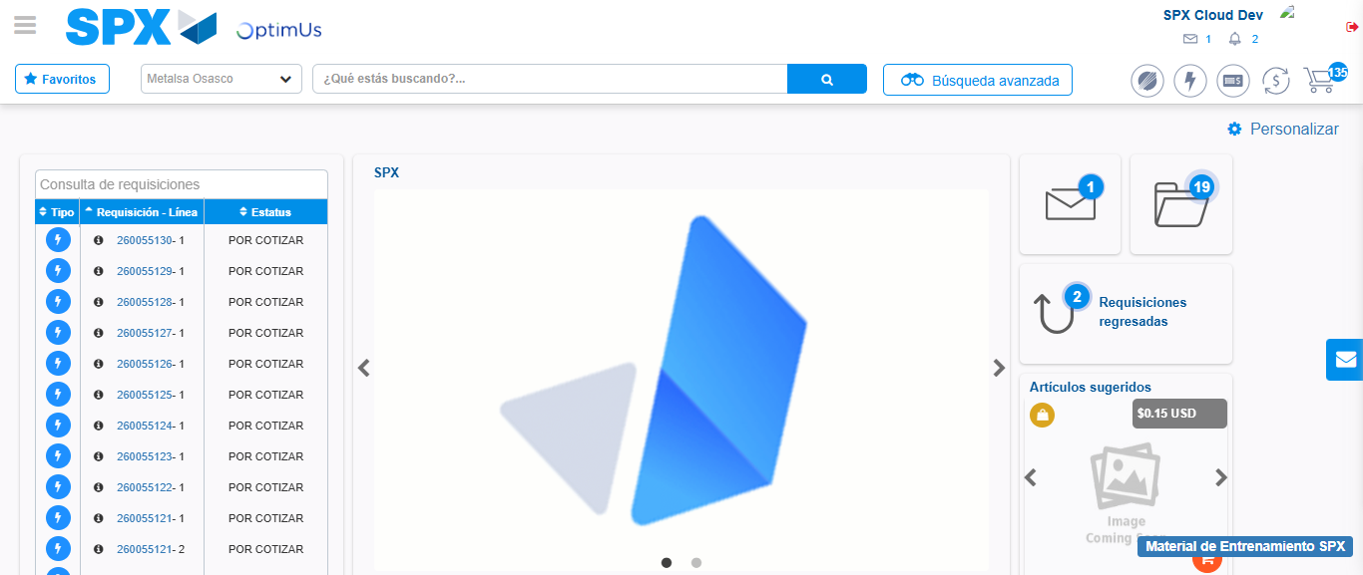Image file-name: QC_Testing-tc001_SPX_Dev5_Crear_Nueva_Linea_Requisicion_Spot_Tipo_Cobro_CC-1790176413690

Step 9 - Log Out : Log Out SPX
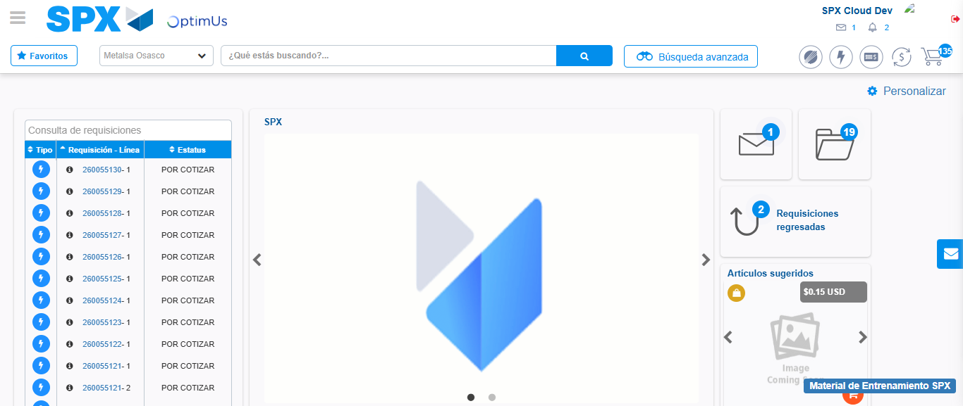Image file-name: QC_Testing-tc001_SPX_Dev5_Crear_Nueva_Linea_Requisicion_Spot_Tipo_Cobro_CC-1790176414001

